**RUTA MAS CORTA**

Encuentre la ruta más corta de 1 a todos los nodos

Nota: Solo en este ejercicio, asuma que distTo y edgeTo comienzan con el índice 1

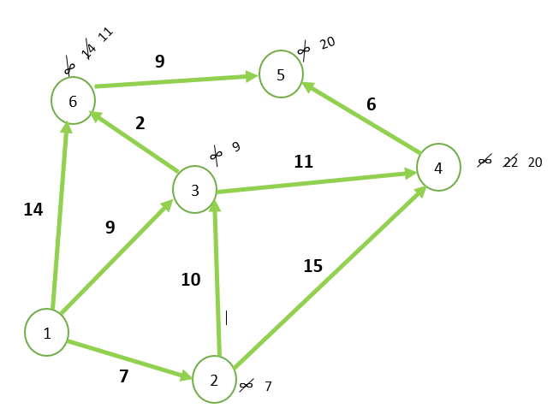

|  |  |  |
| --- | --- | --- |
| V | DistTo [ ] | EdgeTo[ ] |
| 1 | 0.0 | - |
| 🡪 2 | 7.0 | 1 🡪 2 |
| 3 | 9.0 | 1 🡪 3 |
| 4 | 22.0 | 1 🡪 6 |
| 5 |  |  |
| 6 | 14.0 | 1 🡪 6 |

|  |  |  |
| --- | --- | --- |
| V | DistTo [ ] | EdgeTo[ ] |
| 🡪 1 | 0.0 | - |
| 2 | 7.0 | 1 🡪 2 |
| 3 | 9.0 | 1 🡪 3 |
| 4 |  |  |
| 5 |  |  |
| 6 | 14.0 | 1 🡪 6 |

|  |  |  |
| --- | --- | --- |
| V | DistTo [ ] | EdgeTo[ ] |
| 1 | 0.0 | - |
| 2 | 7.0 | 1 🡪 2 |
| 3 | 9.0 | 1 🡪 3 |
| 4 | 20.0 | 3 🡪 4 |
| 5 | 20.0 | 6 🡪 5 |
| 🡪 6 | 11.0 | 3 🡪 6 |

|  |  |  |
| --- | --- | --- |
| V | DistTo [ ] | EdgeTo[ ] |
| 1 | 0.0 | - |
| 2 | 7.0 | 1 🡪 2 |
| 🡪 3 | 9.0 | 1 🡪 3 |
| 4 | 20.0 | 3 🡪 4 |
| 5 |  |  |
| 6 | 14.0 | 1 🡪 6 |

**La ruta mas corta que se puede tomar es:**

|  |  |  |
| --- | --- | --- |
| V | DistTo [ ] | EdgeTo[ ] |
| 1 | 0.0 | - |
| 2 | 7.0 | 1 🡪 2 |
| 3 | 9.0 | 1 🡪 3 |
| 4 | 20.0 | 3 🡪 4 |
| 5 | 20.0 | 6 🡪 5 |
| 6 | 11.0 | 3 🡪 6 |